

**FitMe**

*The Website to help confined couch potatoes get in shape*

Maria Clara Correia Soares

up201604154@fe.up.pt

Turma 2

Gustavo Manuel Esteves Pelayo

up201604154@fe.up.pt

Turma 2

**Project Description**

A university wants a developer to make a website and a database to encourage students to practice sport in confinement.

Each student has an identifying number, a name, fitness level. The identifying number must be unique for every student.

The database should also store information regarding every muscle group to train. Each muscle group must have a name and different recommended exercises.

Every muscle group must have a list of exercises.

Every exercise has a name, difficulty and a corresponding muscle group.

When an exercise is completed the following data must be stored: the name of the exercise, the student who completed it, the fitness level and the muscle group.

When a student completes an exercise, his/her fitness level is increased depending on the exercise difficulty. When a student repeats an exercise a certain number of times, his/her ranking for that exercise is increased.

UML Class Diagram

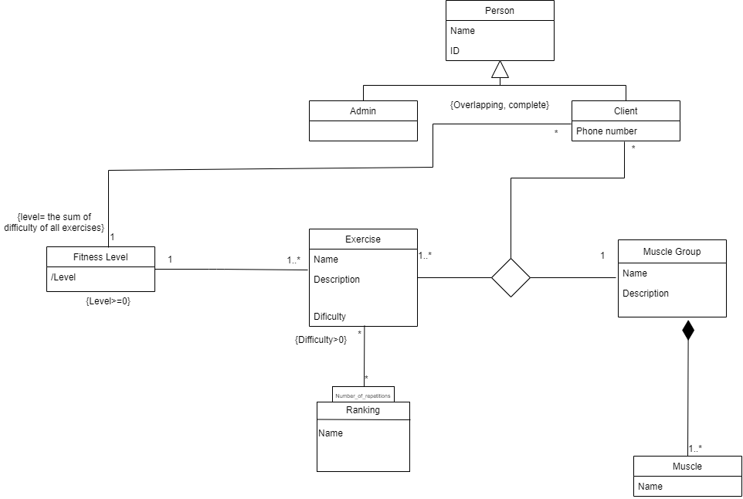

Relational Model

Person (ID, Name)

NotNull(Name)

Admin (ID->Person)

Client (ID->Person, Phone number)

Exercise (Name, Description, Difficulty, fitnesslevel->FitnessLevel)

NotNull(FitnessLevel)

NotNull(Description)

Check(Difficulty>0)

Ranking(Name)

NotNull(Exercise)

Positions(Name->Exercise, Name->Ranking, Number_of_Repetition)

Muscle Group(Name, Description)

Muscle(Name, Name->Muscle Group)

NotNull(Muscle)

FitnessLevel (/Level)

Check(Level>=0)

ExerciseMuscleGroupCliente(NameExercise->Exercise, NameMuscleGroup->MuscleGroup, IDClient->Client) //associação ternaria